Implementation of Novel Machine Learning Methods for Analysis and Detection of Fake Reviews in Social Media
Dr. D.Ganesh  Associate Professor of CSE,  Mohan Babu University  (Erstwhile Sree Vidyanikethan Engineering College(Autonomous), Tirupati, Andhra Pradesh , India  ganesh.d@vidyanikethan.edu | Mr. K.Jayanth Rao  UG Scholar , Department of CSE,  Sree Vidyanikethan Engineering College(Autonomous), Tirupati, Andhra Pradesh , India  kuntejayanthrao2002@gmail.com | Dr. M.Sunil Kumar  Professor of CSE,  Mohan Babu University  (Erstwhile Sree Vidyanikethan Engineering College(Autonomous), Tirupati, Andhra Pradesh , India  sunilmalchi@vidyanikethan.edu
Ms.M.Vinitha  UG Scholar , Department of CSE,  Sree Vidyanikethan Engineering College(Autonomous), Tirupati, Andhra Pradesh , India | Ms.M.Anitha  UG Scholar , Department of CSE,  Sree Vidyanikethan Engineering College(Autonomous), Tirupati, Andhra Pradesh , India | Mr.S.Sai Likith &  Ms.Racheal Taralitha  UG Scholars , Department of CSE,  Sree Vidyanikethan Engineering College(Autonomous), Tirupati, Andhra Pradesh , India

ABSTRACT
Now-a-days social media plays a key role in our daily life. For many things we rely on this social media. This social media plays a very crucial role in several fields. People started believing the things which are written in internet before taking their decisions, such as having a look on reviews which are written in the social media for various purposes like buying a product in online or booking a hotel room for vacation or for visiting a place, for all these things people rely on these reviews which are written by several people. By these reviews there will be advantages as well as disadvantages. Some people to improve their company standards or for high-lightening their products, they generate few fake reviews which attracts the users towards them and by that people starts choosing them. A target object's positive ratings may draw more consumers and boost sales, whereas a target object's negative reviews may result in less demand and lower sales. Our research aims to determine if a review is genuine or fraudulent. To avoid these fake reviews and to go with genuine reviews we need a fake review detection system. In this system some machine learning techniques are used. The proposed method consists of machine learning algorithms. They performed a benchmark analysis with different types of (1) traditional ML algorithms like logistic regression (LR), support vector machines (SVM), decision trees (DT), Naive bayes (NB), random forests (RF), & XG Boost (XGB), as well as an ensemble learning approach of such algorithms, and (2) cutting-edge ML algorithms like bidirectional long short-term memory (BILSTM),etc. These algorithms assist in identifying bogus reviews. These algorithms are all contrasted with one another to provide precise results.
Keywords: Naive Bayes (NB), Random forest(RF), Logistic regression(LR) and Decision Tree(DT)
- INTRODUCTION
Reviews are the main information source used by clients today when choosing a service or product. As a result, online reviews are crucial in the decision-making process. For instance, before making a reservation, consumers often read reviews to find out what others' experiences have been like at a particular hotel. Depending on the feedback from the reviews, we will decide whether or not to reserve the room[1]. Users may continue if the majority of reviews are favorable. As a result, most consumers now consider prior evaluations of various internet businesses to be a fairly trustworthy source of information. Evaluations are seen as a way of expressing sincere input about a service, whether favorable or unfavorable, thus any effort to manipulate these reviews by adding false or misleading information is illegal. Such reviews are considered to be false. Each and every one of the reviews that were posted can be trusted. But what if some of these critiques turn out to be inaccurate? Consequently, the investigation of how to spot fake reviews is an important and evolving area of study. The growth of social media has facilitated the spread of misinformation by blurring the lines between editorial content and promotional messages [2]. The use of fake reviews and other forms of fraudulent advertising online is commonplace. Legal groups are now used by the FTC to remind advertisers of their legal obligations and discourage them from doing so. If the permission is utilized in a manner inconsistent with prior FTC administrative processes.
The FTC may be subject to severe civil fines (up to $43,792 per infraction) by delivering criminal offence letters to more than 700 corporations. You are cautioned that Samuel Levine, director of the FTC's Bureau of Consumer Protection, stated: "Advertisers pay the price for engaging in these misleading activities[3-7]." The Notice of Crimes Offenses supplements the Consent Order by authorizing the agency to seek civil fines against corporations that engaged in conduct that was explicitly forbidden by prior FTC executive orders.
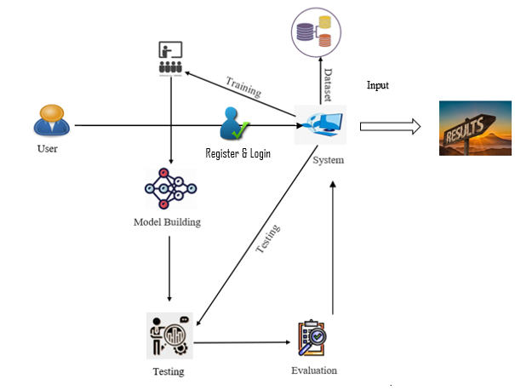
Notices sent to businesses list a variety of actions that the FTC has ruled in prior administrative cases to be unfair or misleading. Among them are, but not restricted to: falsely claiming to be an actual user, a current user, or a recent user. Use notifications to make erroneous assertions. They had no unanticipated material link with the referrer that was disclosed. Misrepresenting the Promoter's experience as a representative of the average or normal consumer experience. Therefore, we need an accurate [8-10]

Figure 1.General Procedure for Detecting Fake News
Issues have arisen on customer review websites because of the open nature of user remarks and their subsequent use. On social media platforms (like Twitter, Face book, etc.), users are free to express their opinions about any company at any time[11]. Some companies take advantage of the lack of regulation in social media to unfairly promote their goods, brands, and stores, or to badmouth their rivals. Consider a scenario in which a few customers who purchased a certain digital camera filed reviews that were critical of the image quality. These evaluations give the public a negative impression of the digital camera. As a result, the camera maker could hire someone or a group to create fictitious good evaluations about the camera[12]. Similar to this, the manufacturer can instruct the paid individuals to publish critical remarks about rival companies' goods in order to promote the business. Reviews that are provided by persons who haven't used the products themselves are regarded as phoney reviews. As a result, someone who uploads false reviews is referred to as a spammer. Spammers are referred to as a group of spammers when they collaborate to accomplish a common objective [13-17].The issues of fake review identification have been the subject of several investigations. Classifying a review as false or real is the primary task involved in fake review detection. In order to better pinpoint current issues for potential future approaches in this field of study, we have offered a thorough literature review in this survey report. It provides researchers with deep learning and traditional statistical machine learning methods so they can pick the most efficient machine learning methodology for identifying fake reviews. Papers in Google Scholar, the Web of Science, and other scholarly repositories, as well as proceedings from notable conferences, are used to demonstrate the challenges inherent in identifying fake reviews [18].
The Remaining Paper is organized as Follows. Section 2 Provides the Literature survey of Latest research on Fake news Detection. Section 3 Provides the Proposed Methodology and Algorithm for detecting the Fake News. Section 4 provides the comparisons and results of proposed system with existing methods. Finally Section5 concludes the paper.
2. Related Works
In academia, the term "literature review" refers to a comprehensive summary of relevant research. The literature review is a systematic examination of relevant published works in a particular topic of study. The review should document, describe, summarize, objectively evaluate, and clarify this earlier work.
N. Jindal and B. Liu [6] discusses about Accepting customer reviews as a basic feature of online stores has been the norm in recent years. Reviews like this are great for learning more about a product before you buy it. Users consult them before making a purchase to find out what others think of the product. Manufacturers can use them to learn about their goods' flaws and to gather information about their competitors[19]. The power of reviews, however, also makes them a prime target for spammers who use them to spread either fake praise or malicious criticism. In this article, we will cover recent research on spam and spam detection.
Leman Akoglu, Christos Faloutsos, and Rishi Chandy[4]. Network effects-based opinion fraud detection in online reviews. The Web has significantly improved how individuals carry out certain tasks, locate information, and communicate with one another. Nowadays, a lot of individuals read and post reviews on social media, blogs, forums, and merchant websites before and after making purchases of goods and services. Negative reviews can harm the reputation and result in financial loss, whilst good reviews with high ratings can result in financial advantages. As news flows over the Internet, this impact is amplified [20]. Online review platforms are therefore appealing candidates for opinion falsification. Reviewers who write false reviews are committing opinion fraud. Online user evaluations may have a big impact on how well hotels, restaurants, and other businesses do.
What Yelp's false review filter may be doing is discussed by A. Mukherjee, V. Venkataraman, B. Liu, and N. Glance [5] . It's become increasingly common to consult user evaluations while making a purchase. Yelp, however, has been systematically erasing user evaluations for the past five years. However, the Yelp algorithm is a well guarded secret[21]. This research looks at the filtered reviews on Yelp to see what the company might be up to. Filtering can be done in two primary ways: supervised learning and unsupervised learning. Linguistic qualities and behavioural characteristics are the two most common types of characteristics. All existing supervised learning techniques rely on bogus reviews that haven't been verified by a commercial entity[23-26]. There has been recent evidence showing that supervised learning using linguistic n-gram features is highly effective (above 90% accuracy) at detecting fake Amazon Mechanical Turk reviews generated through crowd sourcing (AMT).
"The Business Value of Customer Reviews and Recommendations The proliferation of online marketplaces is largely attributable to the popularity of services like Airbnb, Uber, and Taobao. These marketplaces are popular because they promote trust through reputation and feedback systems, in addition to making it easy for buyers and sellers to connect. I begin by presenting the core notions around the importance of reputation in encouraging trust and trade in online markets and offering an outline of how feedback and reputation systems work in these venues. We next explain studies that analyze how online marketplaces are affected by reputation and feedback systems, and we point out some of the bias issues that exist in these kinds of systems at present. For the purpose of making online marketplace designs more user-friendly, I discuss potential solutions to these problems and propose areas of inquiry for additional research.
Opinion mining & sentiment analysis, by C. C. Aggarwal, [4]. Recent advances in social media have made it possible for users to express their views on a wide range of topics in both professional and casual settings. Blogs, discussion forums, social media posts, online forums, and reviews are all viable alternatives. Opinion mining & sentiment analysis is the field of study concerned with the computer analytics of such text[27].
"Data mining: Web data gathering approaches, tools, and algorithms: An overview," by M. J. H. Mughal [3]. Web data mining is the user-friendly and vital platform for the retrieval of useful information. Internet users voluntarily share and save media files online. The proliferation of online content makes it harder and more time-consuming to locate relevant information and trends. Unstructured and inconsistent online content makes it challenging to glean the precise, user-requested data. Several mining methods are used to sift through the vast amounts of data that make up the World Wide Web and extract the information that is actually useful. Internet-centric data mining is known as "web data mining." There are three main types of web data mining: usage, content, and structure. Each of these fields uses a unique combination of tactics, software, and algorithms to sift through massive amounts of digital data in search of useful insights[28].
R. Barbado, O. Araque, & C. A. Iglesias, [1] "A framework for false review identification in consumer online electronics merchants." Business success in several sectors, from hospitality and dining to e-commerce, is increasingly determined on customer feedback provided in the form of online ratings and reviews. Unfortunately, there are others who would fabricate reviews of their competitors or even their own company in an effort to improve their internet standing. The detection of fake reviews has been the subject of numerous research projects, and this includes the hospitality industry. This article proposes a feature structure for use in the industry of consumer electronics with the goal of identifying reviewed erroneous evaluations. This entails four different kinds of input: The objectives of this research were to construct a dataset for classifying fake reviews in the consumer electronics industry by scraping websites in four different cities; to define a feature framework for review spam detection; to design a method for classifying fake reviews based on the suggested framework; and to evaluate and analyze the results in each city. According to the Friedman test and other statistical approaches, the Ada Boost classification has been proven to be the most effective, and we have succeeded in the classification task with an F-Score of 82%[29].
P Hajek, A Barushka, M Munk[8] Due to the rise in online transactions, fake customer review detection has garnered a lot of attention recently. The review content, product information, reviewer information, and other factors are used in existing methods to identify false customer reviews. Recent research, however, suggests that the semantic significance of reviews may be particularly significant for text categorization[30].
Gourav Bathla, Pardeep Singh, Rahul Kumar Singh, Erik Cambria & Rajeev Tiwari [29],"A Review-and-Reviewer based method for Fake Review Detection," pp. 1-6. This study combines the review-based technique with the reviewer-based approach to phoney review identification, primarily for online hotel reviews. The review text data is processed using a variety of Natural Language Processing techniques, including tokenization, lemmatization, vectorization, etc., to extract useful characteristics. The data is utilised to train various classification models utilising machine learning techniques that can identify false reviews after text mining."Fake Reviews Filtering Systems Using Supervised Machine Learning," by Deepanshu Jain, Sayam Kumar, and Yashika Goyal. As the number of people who regularly access the internet rises, so does the significance of the review sites system. Businesses' reputations and bottom lines could be directly affected by the veracity of online evaluations, making this issue vital for all involved. It's crucial for changing people's minds about a product or service. The findings of this research not only indicate a more adaptable and user-friendly website, but also provide some insight into the most efficient approach for identifying and removing fake reviews. Users will benefit much from and be profoundly impacted by the website. The overall literature is as shown in the below Table 1.

Table 1.Summary of the Literature Survey
S.No | Name of the Authors | Year of founding | Proposed system
1 | N.Jindal  B.Liu [6] | 2007 | Review spam detection
2 | Leman Akoglu,  Rishi Chandy, and  Christos Faloutsos [4] | 2013 | Opinion fraud detection in  online reviews by network effects.
3 | A. Mukherjee,  V. Venkataraman,  B. Liu, and N. Glance [5] | 2013 | fake review filters
4 | Tadelis [2] | 2016 | The economics of reputation and feedback systems in e-commerce marketplaces
5 | C.N. Agarwala [4] | 2018 | Sentiment analysis and data mining in machine learning
6 | M. J. H. Mughal [2] | 2018 | Web data mining techniques
7 | R. N.Barbadoue[1]  O. Araque  C. A. Lglesias | 2019 | Methodology for Identifying Fake Reviews
8 | Dinooshi Poornima Jayathunga, [8] | 2021 | Deceptive Review Identification Using Linguistic Inquiry and Word Count
9 | Ahmed M. Elmogy, Usman Tariq , Atef Ibrahim [28] | 2021 | An Approach to Identifying Fake Reviews Based on Reviews and Reviewers
10 | Gourav Bathla, Pardeep Singh, Rahul Kumar Singh, Erik Cambria & Rajeev Tiwari [29] | 2022 | Supervised machine learning for filtering fake reviews

3. Methodology:
The classifiers were generated using many machine-learning models that were initially built using various machine-learning models to analyze the dataset examples. The models that performed the best among these were chosen as prospective elements. They identified the reusable components by examining their misjudgments. Then, to obtain better performance, a unified model was created. Figure 3 depicts the overall methodology, which would be described as follows:
3.1 Dataset used:
We utilize the anemia dataset for machine-learning predictions of fake reviews.
Characteristics of Dataset: Multivariate
Total Number of Instances: 9439
Attribute Characteristics: Real
Total Attributes: 26, Missing Values- Yes.

3.2 Block diagram:
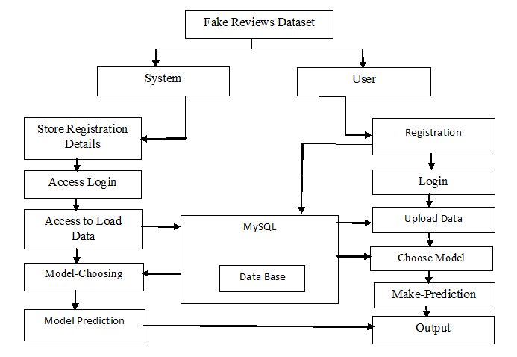
The below block Diagram describes the basic steps to detect the fake reviews using a machine-based learning approach. The proposed algorithm is as shown in Table 2

Fig 2. Proposed Procedure for Fake News Detection
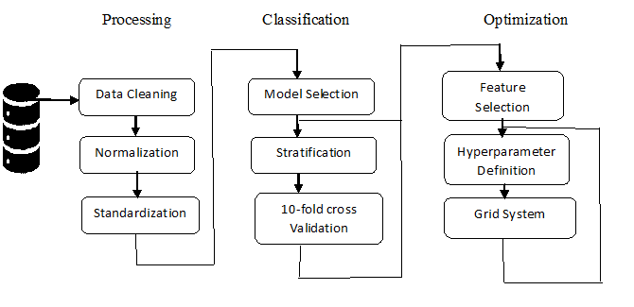

Figure 3 Various Phases during the Detection Method
Table 2.Proposed Algorithm for Fake News Detection
Input: Anemia Dataset
Output: Predicted Results based on the tests values from the Data set.
- Anemia Dataset must first be imported into the model to begin the procedure.
- After pre-processing the data, use the dataset to forecast the fake reviews detection.
- The captured data must now be trained before it can be evaluated and classified.
- After classification, apply machine learning techniques to the categorized dataset.
- Thenwecanforecastandexaminethealgorithmsthatassistusinproducingtheoutcomeandterminating the process.

3.3 Preprocessing:
Data preprocessing is a technique that may be used to transform unclean information into a tidy dataset. Each method for a machine learning classifier requires training as a fundamental step. This method completes tasks including managing unclear values, downscaling the data, creating binary data from it, and standardizing the data frame. When upgrading the dataset, a stronger tendency is utilized when the collection of characteristics had scales that varied. The value has been transformed into 0 and 1 using the binary transformation. Every attribute's value is regarded as either 1 for values above the threshold or 0 for values below the threshold. Each attribute must have a mean value of 0 and a standard deviation of 1 according to the standardized technique as shown in figure 4
Fig 4 Pre Processing Mechanism
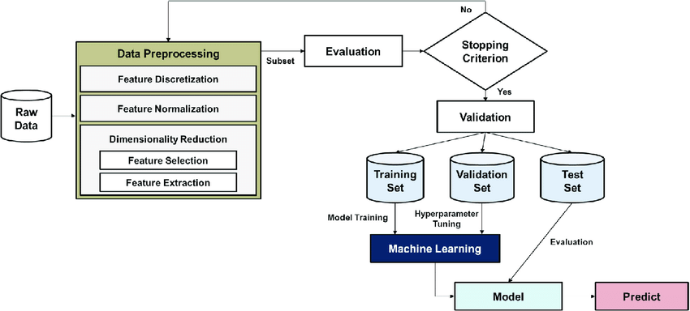
3.4 Feature Selection:
Every machine-based learning algorithm needs feature selection before training if outcomes may be collisions if extrinsic attributes are left in the dataset. The classifier technique with feature extraction improves performance and cuts down on the model's runtime. Three distinct feature selection techniques were employed in this approach.
3.4.1 Embedded Method and Wrapper Method:
The technique for choosing the right feature is to use a filter. Without using any training classifier technique, it chooses features based on their key aspects. Relative to the wrapper technique, this approach yields results more quickly. According to the statistical correlation between each feature and its grade, the approach awards scores to each one. Correlation-based Feature Selection (CFS) is one of several other strategies that may be utilized, but it has been employed. The CFS algorithm uses attribute rankings to choose the feature. The correlation heuristic evaluation function is used to provide ranks to attribute subsets. The function utilizes a method that generates 2-class designations, the first of which is lowly connected with status and the other is, and it chooses the characteristics of the labels that are correlated to class.
3.4.2 Wrapper Method:
A precise machine-learning approach is used by this method to choose features subset. A potential subset of characteristics was located using the greedy search technique. The methods for forward selecting, sequential backward, and recursive removal can all be used to carry out the technique. The forward feature selection strategy was employed in the study. The forward selection chooses the feature iteratively. This process begins with a void model, iterates, and adds the attribute at each stage. The characteristic will continue to be added to the model until it no longer enhances model performance.
3.4.3 Embedded Method:
A decision tree method is utilized in the embedded technique for feature engineering. It divides a smaller subgroup of the data set and picks the objectives in each phase that functions accurately as the tree grows. The most widely used algorithms for decision trees are ID3, C4.5, and CART. There are several techniques for building linear models. LASSO with a Ridge receives an L2 default and L1 penalties are the two most used techniques. The LASSO method was employed in this study. Normalization and extraction of features are its two primary functions. Some feature coefficients are reduced to zero during batch normalization, indicating that the characteristics are not significant for the prediction model.
4. Prediction and Evaluation:
4.1 Confusion Matrix Description:
- True Positive (TP) refers to an output that is positive in the sense that the result is accurately classified.
- True Negative (TN) refers to negative output for the result to be correctly classified.
- False Positive (FP) refers to an outcome that is positive but not as expected.
- False Negative (FN) refers to output that is negative so that the projected result is misclassified.
4.2 Accuracy:

The accuracy of the classification shows the likelihood that forecasts will come true. To calculate it, utilize the confusion matrix.
Accuracy = ------- (1)
4.3Recall:

Recall plays a significant role in the evaluation of the model's performance. It is the percentage of linked instances about all retrieved instances.
Recall = -------------(2)

4.4 Precision:
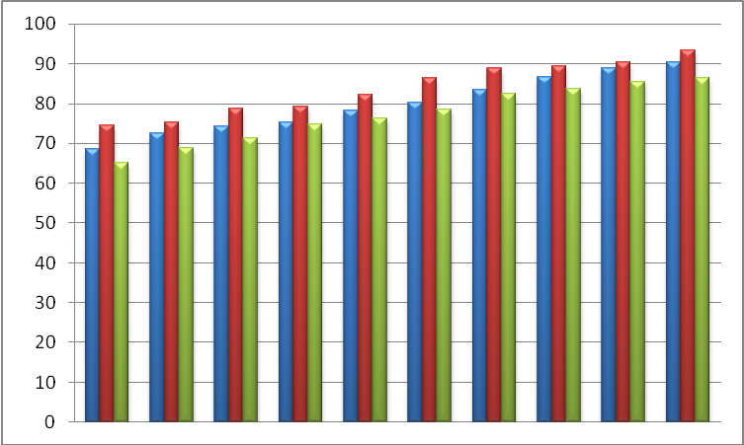
The model performance evaluation matrix includes precision as a key factor. Instances that are connected as a percentage of all retrieved instances make up this percentage. It has a projected value that is favorable.

Precision = --------------(3)
4.5.F-Measure:
It also goes by the name F Score. To gauge test accuracy, the F-measure is calculated.
F-Measure = ---------------(4)
4.6. Comparison of Proposed System With Existing Algorithms:
The evaluated algorithms for the detection of fake reviews are Random forest, KNN, SVM, BERT, CNN, XG Boost, ANN, LSTM, Decision tree and Logistic Regression. Various parameters used to verify the algorithms are Classification Accuracy, Precision, Recall and F-Measure. The proposed methods are evaluated using MATLAB R2018 edition. After careful evaluation of all the algorithms in MATLAB as per the parameters considered the evaluated outputs are shown in Tables 3 &4
Table 3. Evaluated Results of Various Algorithms for the detection of fake reviews
S. No. | Model | Precision Score  (%) | Recall  Score  (%) | F1  Score (%)
1 | ANN | 68.59 | 74.56 | 65.23
2 | CNN | 72.59 | 75.25 | 68.89
3 | Logistic Regression | 74.26 | 78.78 | 71.25
4 | Support Vector Machine | 75.28 | 79.12 | 74.89
5 | Gaussian Naive Bayes | 78.28 | 82.15 | 76.25
6 | K-Nearest Neighbor | 80.27 | 86.45 | 78.59
7 | Decision tree | 83.54 | 88.78 | 82.45
8 | Random Forest | 86.54 | 89.45 | 83.78
9 | Stochastic Gradient Descent (SGD) | 88.78 | 90.25 | 85.45
10 | Proposed Multinomial NB(Proposed) | 90.25 | 93.25 | 86.52

Fig 5.Evaluated Results of Various Algorithms for Fake News Detection.
The above table3 and graph 4 shows the comparison of our proposed system with the already proven existing algorithms which shows that our proposed system is ahead of the existing available algorithms.
Table 4.Comparison of Various Models in terms of Training and Testing Accuracy
Model | Training accuracy  (%) | Testing  Accuracy (%)
Bidirectional LSTM + GLoVe(50D) | 91.24 | 82.56
LSTM + GLoVe(100D) | 92.56 | 84.56
CNN + LSTM + Doc2Vec +TF-IDF | 93.45 | 85.48
CNN+ Attention+ GLoVe(100D) | 94.58 | 86.75
Bi-LSTM + Attention + GLoVe(100D) | 95.36 | 87.45
CNN + Bi-LSTM + Attention + GLoVe(100D) | 96.58 | 88.56
Logistic Regression + TF-IDF(Proposed) | 98.54 | 89.52
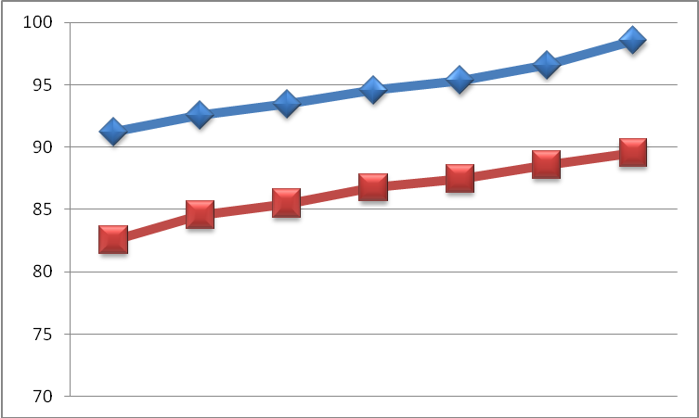

Fig 6. Evaluated Results of Various Hybrid Algorithms in terms of Accuracy
5. Conclusion:
In this work, we have successfully created a mechanism to identify false reviews. With Python programming and the Django framework, this is produced in a user-friendly environment. In order to assess if the review is fraudulent or not, the system is likely to collect information from the user and performs well when compared to the existing mechanisms. Our Proposed system is executed and compared using MATLAB R2018 edition and shown that it works well when compared to the existing algorithms in terms of Various Parameters.
REFERENCES:
- R. Barbado, O. Araque, and C. A. Iglesias, “A framework for fake review detection in online consumer electronics retailers,” Information Processing & Management, vol. 56, no. 4, pp. 1234 – 1244, 2019.
- S. Tadelis, “The economics of reputation and feedback systems in e-commerce marketplaces,” IEEE Internet Computing, vol. 20, no. 1, pp. 12–19, 2016.
- M. J. H. Mughal, “Data mining: Web data mining techniques, tools and algorithms: An overview,” Information Retrieval, vol. 9, no. 6, 2018.
- Leman Akoglu, Rishi Chandy, and Christos Faloutsos. Opinion fraud detection in online reviews by network effects. ICWSM, 13:2–11, 2013.
- Mukherjee, V. Venkataraman, B. Liu, and N. Glance, “What yelp fake review filter might be doing?” in Seventh international AAAI conference on weblogs and social media, 2013.
- N. Jindal and B. Liu, “Review spam detection,” in Proceedings of the 16th International Conference on World Wide Web, ser. WWW ’07, 2007.
- Petr Hájek, Aliaksandr Barushka, Michal Munk "Fake consumer review detection using deep neural networks integrating word embeddings and emotion mining." Neural Comput. Appl. 32(23): 17259 17274 (2020)
- Dinooshi Poornima Jayathunga, R. M. Iranthi Shashikala Ranasinghe, Ramashini Murugiah "A Comparative Study of Supervised Machine Learning Techniques for Deceptive Review Identification Using Linguistic Inquiry and Word Count" Conference paper First Online: 19 January 2021 Part of the Advances in Intelligent Systems and Computing book series (AISC, volume 1321)
- Ganesh, D., et al. "Improving Security in Edge Computing by using Cognitive Trust Management Model." 2022 International Conference on Edge Computing and Applications (ICECAA). IEEE, 2022.
- B. E. Manjunath Swamy. "Personalized Ranking Mechanism Using Yandex Dataset on Machine Learning Approaches." Proceedings of the International Conference on Cognitive and Intelligent Computing: ICCIC 2021, Volume 1. Singapore: Springer Nature Singapore, 2022
- Burada, Sreedhar,"Computer-Aided Diagnosis Mechanism for Melanoma Skin Cancer Detection Using Radial Basis Function Network." Proceedings of the International Conference on Cognitive and Intelligent Computing: ICCIC 2021, Volume 1. Singapore: Springer Nature Singapore, 2022.
- Davanam, Ganesh, T. Pavan Kumar, and M. Sunil Kumar. "Efficient energy management for reducing cross layer attacks in cognitive radio networks." Journal of Green Engineering 11 (2021): 1412-1426.

- Davanam, Ganesh, T. Pavan Kumar, and M. Sunil Kumar. "Novel Defense Framework for Cross-layer Attacks in Cognitive Radio Networks." International Conference on Intelligent and Smart Computing in Data Analytics: ISCDA 2020. Springer Singapore, 2021.
- Kumar, M. S, et al. "Deep Convolution Neural Network Based solution for Detecting Plant Diseases." Journal of Pharmaceutical Negative Results (2022): 464-471.
- Prasad, Tvs Gowtham, et al. "Cnn Based Pathway Control To Prevent Covid Spread Using Face Mask And Body Temperature Detection." Journal of Pharmaceutical Negative Results (2022): 1374-1381.
- Venkateswara Reddy, L., et al. "Bio-Inspired Firefly Algorithm for Polygonal Approximation on Various Shapes." Intelligent Computing and Applications: Proceedings of ICDIC 2020. Singapore: Springer Nature Singapore, 2022. 95-107.
- Kumar, A., Kumar, M. S., Vikhar, P. A., Ghodke, V., Waghulde, R. R., & Rathod, M. (2022). Improving the Software Privacy in the OFDM 5G Communication Integrated with License Key in the Hardware Communication Parameters. International Journal of Intelligent Systems and Applications in Engineering, 10(2s), 236-240.
- Natarajan, V. A., Kumar, M. S., Tamizhazhagan, V., & Chevdumoi, R. M. (2022). Prediction Of Soil Ph From Remote Sensing Data Using Gradient Boosted Regression Analysis. Journal of Pharmaceutical Negative Results, 29-36.
- Kumar, M. Sunil, et al. "Deep Convolution Neural Network Based solution for Detecting Plant Diseases." Journal of Pharmaceutical Negative Results (2022): 464-471.
- P. Sai Kiran, and M. S Kumar. "Resource aware virtual machine placement in IaaS cloud using bio-inspired firefly algorithm." Journal of Green Engineering 10 (2020): 9315-9327.
- Balaji, K., P. Sai Kiran, and M. Sunil Kumar. "Power aware virtual machine placement in IaaS cloud using discrete firefly algorithm." Applied Nanoscience (2022): 1-9.
- Kumar, M. Sunil, et al. "APPLYING THE MODULAR ENCRYPTION STANDARD TO MOBILE CLOUD COMPUTING TO IMPROVE THE SAFETY OF HEALTH DATA." Journal of Pharmaceutical Negative Results (2022): 1911-1917.
- Davanam, Ganesh, T. Pavan Kumar, and M. Sunil Kumar. "Efficient energy management for reducing cross layer attacks in cognitive radio networks." Journal of Green Engineering 11 (2021): 1412-1426.
- Davanam, Ganesh, T. Pavan Kumar, and M. Sunil Kumar. "Novel Defense Framework for Cross-layer Attacks in Cognitive Radio Networks." International Conference on Intelligent and Smart Computing in Data Analytics. Springer, Singapore, 2021.
- Walde, R.B., Prakash, O., Kumar, M.S., Sule, B., Nabilal, K.V. and Pawar, U.C., 2023. Ranking Based Security Scheme with Attack Detection and Improved Network Security. International Journal of Intelligent Systems and Applications in Engineering, 11(3s), pp.35-41
- Yadav, S.S., Maan, M.K., Kumar, M.S., Kumarnath, J., Pund, S.S. and Rathod, M., 2023. A Secure IoT Smart Network Model for the Contributory Broadcast Encryption for the Text Policy Management Scheme. International Journal of Intelligent Systems and Applications in Engineering, 11(3s), pp.42-48.

- Kumar, A., Kumar, M. S., Vikhar, P. A., Ghodke, V., Waghulde, R. R., & Rathod, M. (2022). Improving the Software Privacy in the OFDM 5G Communication Integrated with License Key in the Hardware Communication Parameters. International Journal of Intelligent Systems and Applications in Engineering, 10(2s), 236-240.
- Ahmed M. Elmogy, Usman Tariq , Atef Ibrahim ”Fake Reviews Detection using Supervised Machine” Learning (IJACSA) International Journal of Advanced Computer Science and Applications, Vol. 12, No. 1, 2021.
- Gourav Bathla, Pardeep Singh, Rahul Kumar Singh, Erik Cambria & Rajeev Tiwari "Intelligent fake reviews detection based on aspect extraction and analysis using deep learning "Neural Computing and Applications 34, 20213-20229 (2022).
- Y. Ren and D. Ji, “Neural networks for deceptive opinion spam detection: An empirical study,” Information Sciences, vol. 385, pp. 213– 224, 2017.

